Structured Programming Approach (FEC205) – FE SEM 2
- Write a C program to print your name, date of birth. and mobile number.

#include <stdio.h>
int main()
{
printf("Name : Yogesh Pingle\n");
printf("DOB : July 07, 1977\n");
printf("Mobile : 91-9422492389\n");
return(0);
}

- Write a C program to print a block F using hash (#), where the F has a height of six characters and width of five and four characters.

#include <stdio.h>
int main()
{
printf("######\n");
printf("#\n");
printf("#\n");
printf("#####\n");
printf("#\n");
printf("#\n");
printf("#\n");

return(0);
}

- Write a C program to compute the perimeter and area of a rectangle with a height of 7 inches and width of 5 inches.

A perimeter is a path that surrounds a two-dimensional shape. The word comes from the Greek peri (around) and meter (measure). The perimeter can be used to calculate the length of fence required to surround a yard or garden. For rectangles or kites which have only two different side lengths, say x and y, the perimeter is equal to 2x + 2y

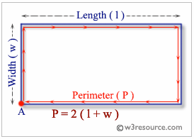

The area of a two-dimensional figure describes the amount of surface the shape covers. You measure area in square units of a fixed size, square units of measure are square inches, square centimeters, or square miles etc. The formula for the area of a rectangle uses multiplication: length • width = area. A rectangle with four sides of equal length is a square.
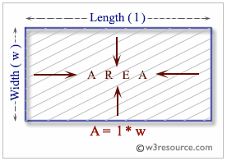

#include <stdio.h>
/* height and width of a rectangle in inches */
int width;
int height;

int area;
int perimeter;

int main() {
height = 7;
width = 5;

perimeter = 2*(height + width);
printf("Perimeter of the rectangle = %d inches\n", perimeter);

area = height * width;
printf("Area of the rectangle = %d square inches\n", area);

return(0);
}

- Write a C program that accepts an employee's ID, total worked hours of a month and the amount he received per hour. Print the employee's ID and salary (with two decimal places) of a particular month.

#include <stdio.h>
int main() {
char id[10];
int hour;
double value, salary;
printf("Input the Employees ID(Max. 10 chars): ");
scanf("%s", &id);
printf("\nInput the working hrs: ");
scanf("%d", &hour);
printf("\nSalary amount/hr: ");
scanf("%lf", &value);
salary = value * hour;
printf("\nEmployees ID = %s\nSalary = U$ %.2lf\n", id,salary);
return 0;
}
Sample Output:
Input the Employees ID(Max. 10 chars): 0342

Input the working hrs: 8

Salary amount/hr: 15000

Employees ID = 0342
Salary = U$ 120000.00

- Write a C program that accepts a distance in centimeters and prints the corresponding value in inches.
Note: 1 inch = 2.54 cm.
#include <stdio.h>
#define INCH_TO_CM 2.54
int main()
{
double inch, cm;
printf("Input the distance in cm:\n");
scanf("%lf", &cm);
inch = cm / INCH_TO_CM;
printf("Distance of %0.2lf cms is = %0.2lf inches\n", cm, inch);
return 0;
}

Sample Output:
Input Data: 500cms
Input the distance in cm:
Distance of 500.00 cms is = 196.85 inches

- Write a C program that swaps two numbers without using third variable.

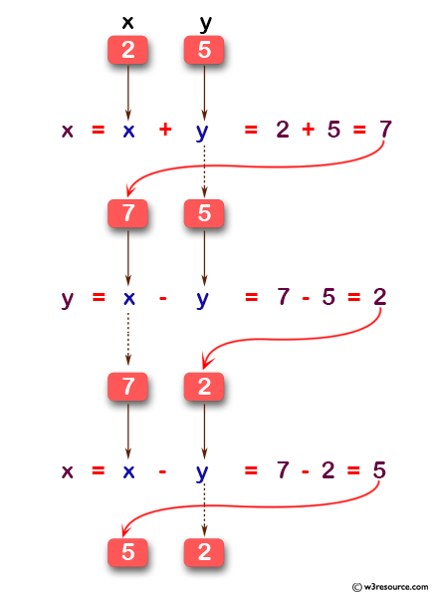
#include<stdio.h>
int main()
{
int x, y;
printf("Input value for x & y: \n");
scanf("%d%d",&x,&y);
printf("Before swapping the value of x & y: %d %d",x,y);
x=x+y;
y=x-y;
x=x-y;
printf("\nAfter swapping the value of x & y: %d %d",x,y);
return 0;
}
Sample Output:
Input value for x & y:
Before swapping the value of x & y: 5 7
After swapping the value of x & y: 7 5

- Write a C program to remove any negative sign in front of a number.
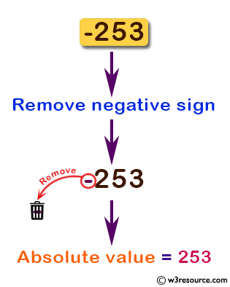
#include<stdio.h>
#define N 10
int main()
{
int uabs(int), x, result;
printf("Input a value (negative): \n");
scanf("%d", &x);
printf("Original value = %d", x);
result= abs_val(x);
printf("\nAbsolute value = %d", result);
return 0;
}

abs_val(int y)
{
if(y<0)
return(y*-1);
else
return(y);
}

Sample Output:
Input a value (negative):
Original value = -253
Absolute value = 253

- Write a C program to accept two integers and check whether they are equal or not.
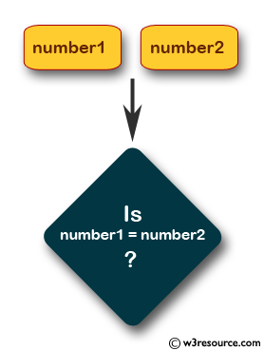
#include <stdio.h>
void main()
{
int int1, int2;

printf("Input the values for Number1 and Number2 : ");
scanf("%d %d", &int1, &int2);
if (int1 == int2)
printf("Number1 and Number2 are equal\n");
else
printf("Number1 and Number2 are not equal\n");
}
Sample Output:
Input the values for Number1 and Number2 : 15 15
Number1 and Number2 are equal

- Write a C program to find whether a given year is a leap year or not.
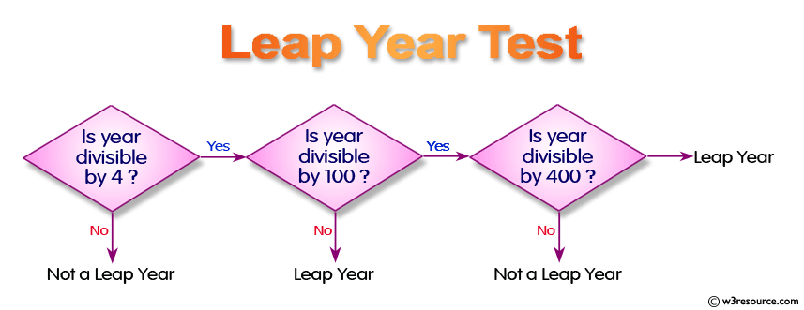
#include <stdio.h>
void main()
{
int chk_year;

printf("Input a year :");
scanf("%d", &chk_year);
if ((chk_year % 400) == 0)
printf("%d is a leap year.\n", chk_year);
else if ((chk_year % 100) == 0)
printf("%d is a not leap year.\n", chk_year);
else if ((chk_year % 4) == 0)
printf("%d is a leap year.\n", chk_year);
else
printf("%d is not a leap year \n", chk_year);
}
Sample Output:
Input a year :2016
2016 is a leap year.

- Write a C program to accept the height of a person in centimeter and categorize the person according to their height.
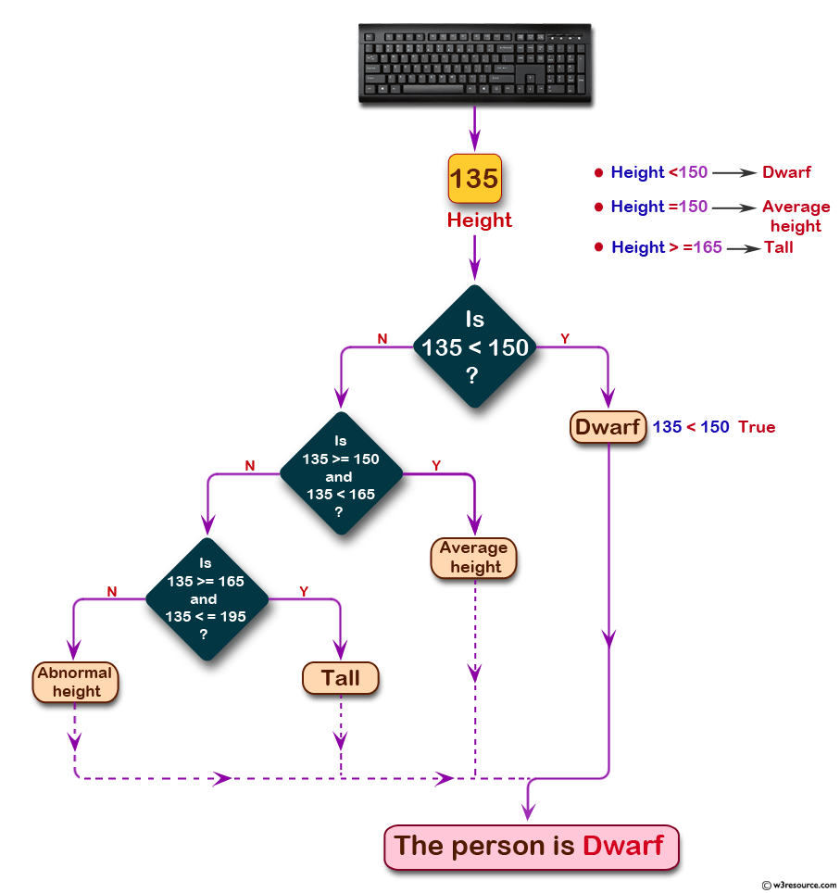
#include <stdio.h>
void main()
{
float PerHeight;

printf("Input the height of the person (in centimetres) :");
scanf("%f", &PerHeight);
if (PerHeight < 150.0)
printf("The person is Dwarf. \n");
else if ((PerHeight >= 150.0) && (PerHeight < 165.0))
printf("The person is average heighted. \n");
else if ((PerHeight >= 165.0) && (PerHeight <= 195.0))
printf("The person is taller. \n");
else
printf("Abnormal height.\n");
}
Sample Output:
Input the height of the person (in centimetres) :135
The person is Dwarf.

- Write a C program to find the largest of three numbers.

#include <stdio.h>
void main()
{
int num1, num2, num3;

printf("Input the values of three numbers : ");
scanf("%d %d %d", &num1, &num2, &num3);
printf("1st Number = %d,\t2nd Number = %d,\t3rd Number = %d\n", num1, num2, num3);
if (num1 > num2)
{
if (num1 > num3)
{
printf("The 1st Number is the greatest among three. \n");
}
else
{
printf("The 3rd Number is the greatest among three. \n");
}
}
else if (num2 > num3)
printf("The 2nd Number is the greatest among three \n");
else
printf("The 3rd Number is the greatest among three \n");
}

Sample Output:
Input the values of three numbers : 12 25 52
1st Number = 12, 2nd Number = 25, 3rd Number = 52
The 3rd Number is the greatest among three

- Write a C program to read temperature in centigrade and display a suitable message according to temperature state below :
Temp < 0 then Freezing weather
Temp 0-10 then Very Cold weather
Temp 10-20 then Cold weather
Temp 20-30 then Normal in Temp
Temp 30-40 then Its Hot
Temp >=40 then Its Very Hot
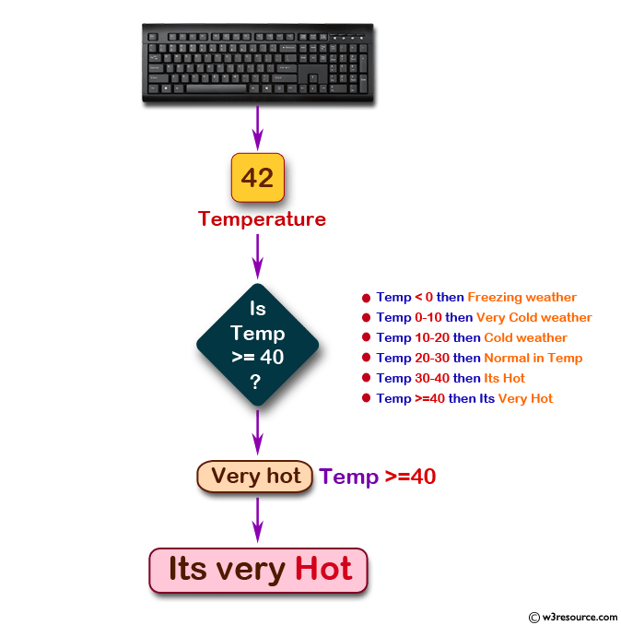
#include <stdio.h>
void main()
{
int tmp;

printf("Input days temperature : ");
scanf("%d",&tmp);
if(tmp<0)
printf("Freezing weather.\n");
else if(tmp<10)
printf("Very cold weather.\n");
else if(tmp<20)
printf("Cold weather.\n");
else if(tmp<30)
printf("Normal in temp.\n");
else if(tmp<40)
printf("Its Hot.\n");
else
printf("Its very hot.\n");

}
Sample Output:
Input days temperature : 42
Its very hot.

- Write a program in C to accept a grade and display the equivalent description:
Grade | Description
E | Excellent
V | Very Good
G | Good
A | Average
F | Fail

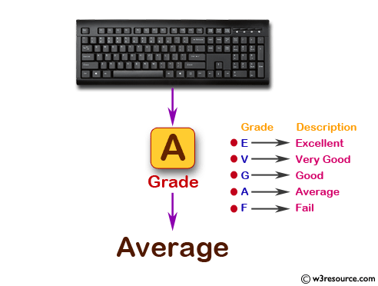
#include <stdio.h>
#include <ctype.h>
#include <string.h>

void main()
{
char notes[15];
char grd;

printf("Input the grade :");
scanf("%c", &grd);

grd = toupper(grd);
switch(grd)
{
case 'E':
strcpy(notes, " Excellent");
break;
case 'V':
strcpy(notes, " Very Good");
break;
case 'G':
strcpy(notes, " Good ");
break;
case 'A':
strcpy(notes, " Average");
break;
case 'F':
strcpy(notes, " Fails");
break;
default :
strcpy(notes, "Invalid Grade Found. \n");
break;
}
printf("You have chosen : %s\n", notes);
}
Sample Output:
Input the grade :A
You have chosen : Average

- Write a C program to find the sum of first 10 natural numbers.
#include <stdio.h>
void main()
{
int j, sum = 0;

printf("The first 10 natural number is :\n");

for (j = 1; j <= 10; j++)
{
sum = sum + j;
printf("%d ",j);
}
printf("\nThe Sum is : %d\n", sum);
}

Sample Output:
The first 10 natural number is :
1 2 3 4 5 6 7 8 9 10
The Sum is : 55

- Write a program in C to display the pattern like right angle triangle using an asterisk.
The pattern like :
*
**
***
****
#include <stdio.h>
void main()
{
int i,j,rows;
printf("Input number of rows : ");
scanf("%d",&rows);
for(i=1;i<=rows;i++)
{
for(j=1;j<=i;j++)
printf("*");
printf("\n");
}
}
Sample Output:
Input number of rows : 10
*
**
***
****
*****
******
*******
********
*********
**********

- Write a program in C to display the pattern like right angle triangle with a number.
The pattern like :
1
12
123
1234

#include <stdio.h>
void main()
{
int i,j,rows;
printf("Input number of rows : ");
scanf("%d",&rows);
for(i=1;i<=rows;i++)
{
for(j=1;j<=i;j++)
printf("%d",j);
printf("\n");
}
}

- Write a program in C to make such a pattern like right angle triangle with a number which will repeat a number in a row.
The pattern like :
1
22
333
4444

#include <stdio.h>
void main()
{
int i,j,rows;

printf("Input number of rows : ");
scanf("%d",&rows);
for(i=1;i<=rows;i++)
{
for(j=1;j<=i;j++)
printf("%d",i);
printf("\n");
}
}

- Write a program in C to make such a pattern like right angle triangle with number increased by 1
The pattern like :
1
2 3
4 5 6
7 8 9 10

#include <stdio.h>
void main()
{
int i,j,rows,k=1;
printf("Input number of rows : ");
scanf("%d",&rows);
for(i=1;i<=rows;i++)
{
for(j=1;j<=i;j++)
printf("%d ",k++);
printf("\n");
}
}

- Write a program in C to make such a pattern like a pyramid with numbers increased by 1
1
2 3
4 5 6
7 8 9 10

#include <stdio.h>
void main()
{
int i,j,spc,rows,k,t=1;
printf("Input number of rows : ");
scanf("%d",&rows);
spc=rows+4-1;
for(i=1;i<=rows;i++)
{
for(k=spc;k>=1;k--)
{
printf(" ");
}
for(j=1;j<=i;j++)
printf("%d ",t++);
printf("\n");
spc--;
}
}

- Write a program in C to make such a pattern like a pyramid with an asterisk.
*
* *
* * *
* * * *

#include <stdio.h>
void main()
{
int i,j,spc,rows,k;
printf("Input number of rows : ");
scanf("%d",&rows);
spc=rows+4-1;
for(i=1;i<=rows;i++)
{
for(k=spc;k>=1;k--)
{
printf(" ");
}

for(j=1;j<=i;j++)
printf("* ");
printf("\n");
spc--;
}
}

- Write a C program to calculate the factorial of a given number.
#include <stdio.h>
void main(){
int i,f=1,num;

printf("Input the number : ");
scanf("%d",&num);

for(i=1;i<=num;i++)
f=f*i;

printf("The Factorial of %d is: %d\n",num,f);
}

Sample Output:
Input the number : 5
The Factorial of 5 is: 120

- Write a program in C to display the n terms of harmonic series and their sum.
1 + 1/2 + 1/3 + 1/4 + 1/5 ... 1/n terms

#include <stdio.h>
void main()
{
int i,n;
float s=0.0;
printf("Input the number of terms : ");
scanf("%d",&n);
printf("\n\n");
for(i=1;i<=n;i++)
{
if(i<n)
{
printf("1/%d + ",i);
s+=1/(float)i;
}
if(i==n)
{
printf("1/%d ",i);
s+=1/(float)i;
}
}
printf("\nSum of Series upto %d terms : %f \n",n,s);
}
Sample Output:
Input the number of terms : 5

1/1 + 1/2 + 1/3 + 1/4 + 1/5
Sum of Series upto 5 terms : 2.283334

- Write a program in C to print the Floyd's Triangle.
1
01
101
0101
10101

#include <stdio.h>

void main()
{
int i,j,n,p,q;
printf("Input number of rows : ");
scanf("%d",&n);
for(i=1;i<=n;i++)
{
if(i%2==0)
{ p=1;q=0;}
else
{ p=0;q=1;}
for(j=1;j<=i;j++)
if(j%2==0)
printf("%d",p);
else
printf("%d",q);
printf("\n");
}
}

- Write a program in C to find the sum of the series 1 +11 + 111 + 1111 + .. n terms.
#include <stdio.h>

void main()
{
int n,i;
long sum=0;
long int t=1;
printf("Input the number of terms : ");
scanf("%d",&n);
for(i=1;i<=n;i++)
{
printf("%ld ",t);
if (i<n)
{
printf("+ ");

}
sum=sum+t;
t=(t*10)+1;
}
printf("\nThe Sum is : %ld\n",sum);
}

Sample Output:
Input the number of terms : 5
1 + 11 + 111 + 1111 + 11111
The Sum is : 12345

- Write a C program to check whether a given number is an armstrong number or not.
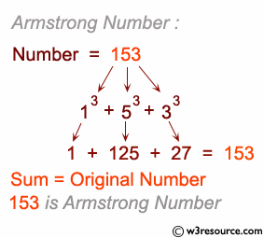
/*When the sum of the cube of the individual digits of a number
is equal to that number, the number is called Armstrong number. For example 153.
Sum of its divisor is 13 + 53;+ 33; = 1+125+27 = 153*/
#include <stdio.h>

void main(){
int num,r,sum=0,temp;

printf("Input a number: ");
scanf("%d",&num);

for(temp=num;num!=0;num=num/10){
r=num % 10;
sum=sum+(r*r*r);
}
if(sum==temp)
printf("%d is an Armstrong number.\n",temp);
else
printf("%d is not an Armstrong number.\n",temp);

}
Sample Output:
Input a number: 153
153 is an Armstrong number.

- Write a program in C to display the pattern like a diamond.
*
***
*****
*******
*********
*******
*****
***
*

#include <stdio.h>

void main()
{
int i,j,r;
printf("Input number of rows (half of the diamond) :");
scanf("%d",&r);
for(i=0;i<=r;i++)
{
for(j=1;j<=r-i;j++)
printf(" ");
for(j=1;j<=2*i-1;j++)
printf("*");
printf("\n");
}

for(i=r-1;i>=1;i--)
{
for(j=1;j<=r-i;j++)
printf(" ");
for(j=1;j<=2*i-1;j++)
printf("*");
printf("\n");
}

}

- Write a C program to determine whether a given number is prime or not.
#include <stdio.h>

void main(){

int num,i,ctr=0;
printf("Input a number: ");
scanf("%d",&num);
for(i=2;i<=num/2;i++){
if(num % i==0){
ctr++;
break;
}
}
if(ctr==0 && num!= 1)
printf("%d is a prime number.\n",num);
else
printf("%d is not a prime number",num);
}

Sample Output:
Input a number: 13
13 is a prime number.

- Write a C program to display Pascal's triangle.
1
1 1
1 2 1
1 3 3 1
1 4 6 4 1

#include <stdio.h>

void main()
{
int no_row,c=1,blk,i,j;
printf("Input number of rows: ");
scanf("%d",&no_row);
for(i=0;i<no_row;i++)
{
for(blk=1;blk<=no_row-i;blk++)
printf(" ");
for(j=0;j<=i;j++)
{
if (j==0||i==0)
c=1;
else
c=c*(i-j+1)/j;
printf("% 4d",c);
}
printf("\n");
}

- Write a program in C to display the first n terms of Fibonacci series.
Fibonacci series 0 1 2 3 5 8 13 .....
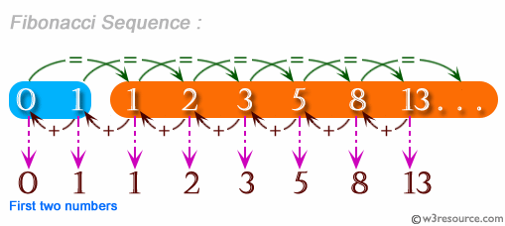
#include <stdio.h>

void main()
{
int prv=0,pre=1,trm,i,n;
printf("Input number of terms to display : ");
scanf("%d",&n);
printf("Here is the Fibonacci series upto to %d terms : \n",n);
printf("% 5d % 5d", prv,pre);

for(i=3;i<=n;i++)
{
trm=prv+pre;
printf("% 5d",trm);
prv=pre;
pre=trm;
}
printf("\n");
}
Sample Output:
Input number of terms to display : 10
Here is the Fibonacci series upto to 10 terms :
0 1 1 2 3 5 8 13 21 34

- Write a program in C to display the number in reverse order.
#include <stdio.h>

void main(){
int num,r,sum=0,t;

printf("Input a number: ");
scanf("%d",&num);

for(t=num;num!=0;num=num/10){
r=num % 10;
sum=sum*10+r;
}
printf("The number in reverse order is : %d \n",sum);
}

Sample Output:
Input a number: 12345
The number in reverse order is : 54321

- Write a program in C to check whether a number is a palindrome or not.

#include <stdio.h>

void main(){
int num,r,sum=0,t;

printf("Input a number: ");
scanf("%d",&num);

for(t=num;num!=0;num=num/10){
r=num % 10;
sum=sum*10+r;
}
if(t==sum)
printf("%d is a palindrome number.\n",t);
else
printf("%d is not a palindrome number.\n",t);

}
Sample Output:
Input a number: 121
121 is a palindrome number.

- Write a program in C to convert a binary number to octal.
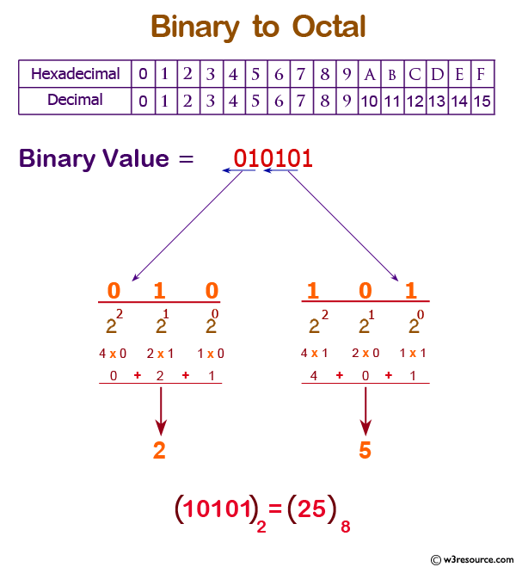
#include <stdio.h>
#include <math.h>

void main()
{ int n1, n,p=1;
int dec=0,i=1,j,d;
int ocno=0,dn;

printf("\n\nConvert Binary to Octal:\n ");
printf("-------------------------\n");

printf("Input a binary number :");
scanf("%d",&n);
n1=n;
for (j=n;j>0;j=j/10)
{
d = j % 10;
if(i==1)
p=p*1;
else
p=p*2;

dec=dec+(d*p);
i++;
}

/*--------------------------------------------*/
dn=dec;
i=1;

for(j=dec;j>0;j=j/8)
{
ocno=ocno+(j % 8)*i;
i=i*10;
n=n/8;
}

printf("\nThe Binary Number : %d\nThe equivalent Octal Number : %d \n\n",n1,ocno);
}
Sample Output:
Convert Binary to Octal:
-------------------------
Input a binary number :1001

The Binary Number : 1001
The equivalent Octal Number : 11

- Write a program in C to print a string in reverse order.
#include <stdio.h>
#include <string.h>

void main()
{
char str1[100], tmp;
int l, lind, rind,i;

printf("\n\nPrint a string in reverse order:\n ");
printf("-------------------------------------\n");

printf("Input a string to reverse : ");
scanf("%s", str1);
l = strlen(str1);

lind = 0;
rind = l-1;

for(i=lind;i<rind;i++)
{
tmp = str1[i];
str1[i] = str1[rind];
str1[rind] = tmp;
rind--;
}

printf("Reversed string is: %s\n\n", str1);
}

Sample Output:
Print a string in reverse order:
-------------------------------------
Input a string to reverse : Welcome
Reversed string is: emocleW

- Write a C program to find the length of a string without using the library function.
#include <stdio.h>
#include <string.h>

void main()
{
char str1[50];
int i, l = 0;

printf("\n\nFind the length of a string:\n ");
printf("-------------------------------------\n");

printf("Input a string : ");
scanf("%s", str1);

for (i = 0; str1[i] != '\0'; i++)
{
l++;
}
printf("The string contains %d number of characters. \n",l);
printf("So, the length of the string %s is : %d\n\n", str1, l);
}
Sample Output:
Find the length of a string:
-------------------------------------
Input a string : welcome
The string contains 7 number of characters.
So, the length of the string welcome is : 7

- Write a program in C to find the sum of all elements of the array.
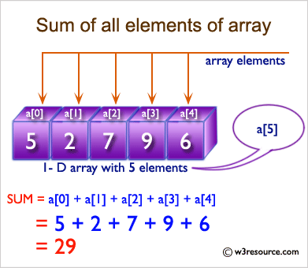

#include <stdio.h>

void main()
{
int a[100];
int i, n, sum=0;

printf("\n\nFind sum of all elements of array:\n");
printf("--------------------------------------\n");

printf("Input the number of elements to be stored in the array :");
scanf("%d",&n);

printf("Input %d elements in the array :\n",n);
for(i=0;i<n;i++)
{
printf("element - %d : ",i);
scanf("%d",&a[i]);
}

for(i=0; i<n; i++)
{
sum += a[i];
}

printf("Sum of all elements stored in the array is : %d\n\n", sum);
}
Sample Output:
Find sum of all elements of array:
--------------------------------------
Input the number of elements to be stored in the array :3
Input 3 elements in the array :
element - 0 : 2
element - 1 : 5
element - 2 : 8
Sum of all elements stored in the array is : 15

- Write a program in C to merge two arrays of same size sorted in decending order.
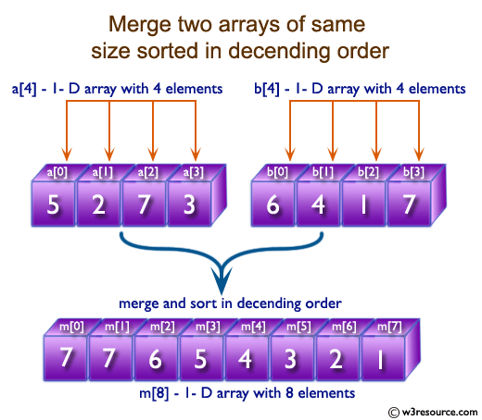
#include <stdio.h>

void main()
{
int arr1[100], arr2[100], arr3[200];
int s1, s2, s3;
int i, j, k;

printf("\n\nMerge two arrays of same size sorted in decending order.\n");
printf("------------------------------------------------------------\n");

printf("Input the number of elements to be stored in the first array :");
scanf("%d",&s1);

printf("Input %d elements in the array :\n",s1);
for(i=0;i<s1;i++)
{
printf("element - %d : ",i);
scanf("%d",&arr1[i]);
}

printf("Input the number of elements to be stored in the second array :");
scanf("%d",&s2);

printf("Input %d elements in the array :\n",s2);
for(i=0;i<s2;i++)
{
printf("element - %d : ",i);
scanf("%d",&arr2[i]);
}

/* size of merged array is size of first array and size of second array */
s3 = s1 + s2;
/*----------------- insert in the third array------------------------------------*/
for(i=0;i<s1; i++)
{
arr3[i] = arr1[i];
}
for(j=0;j<s2; j++)
{
arr3[i] = arr2[j];
i++;
}
/*----------------- sort the array in decending order ---------------------------*/
for(i=0;i<s3; i++)
{
for(k=0;k<s3-1;k++)
{

if(arr3[k]<=arr3[k+1])
{
j=arr3[k+1];
arr3[k+1]=arr3[k];
arr3[k]=j;
}
}
}

/*--------------- Prints the merged array ------------------------------------*/
printf("\nThe merged array in decending order is :\n");
for(i=0; i<s3; i++)
{
printf("%d ", arr3[i]);
}
printf("\n\n");
}
Sample Output:
Merge two arrays of same size sorted in decending order.
------------------------------------------------------------
Input the number of elements to be stored in the first array :3
Input 3 elements in the array :
element - 0 : 1
element - 1 : 2
element - 2 : 3
Input the number of elements to be stored in the second array :3
Input 3 elements in the array :
element - 0 : 1
element - 1 : 2
element - 2 : 3

The merged array in decending order is :
3 3 2 2 1 1

- Write a program in C for addition of two Matrices of same size.
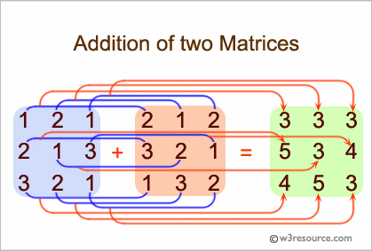
#include <stdio.h>

void main()
{
int arr1[50][50],brr1[50][50],crr1[50][50],i,j,n;

printf("\n\nAddition of two Matrices :\n");
printf("------------------------------\n");
printf("Input the size of the square matrix (less than 5): ");
scanf("%d", &n);

/* Stored values into the array*/
printf("Input elements in the first matrix :\n");
for(i=0;i<n;i++)
{
for(j=0;j<n;j++)
{
printf("element - [%d],[%d] : ",i,j);
scanf("%d",&arr1[i][j]);
}
}

printf("Input elements in the second matrix :\n");
for(i=0;i<n;i++)
{
for(j=0;j<n;j++)
{
printf("element - [%d],[%d] : ",i,j);
scanf("%d",&brr1[i][j]);
}
}
printf("\nThe First matrix is :\n");
for(i=0;i<n;i++)
{
printf("\n");
for(j=0;j<n;j++)
printf("%d\t",arr1[i][j]);
}

printf("\nThe Second matrix is :\n");
for(i=0;i<n;i++)
{
printf("\n");
for(j=0;j<n;j++)
printf("%d\t",brr1[i][j]);
}
/* calculate the sum of the matrix */
for(i=0;i<n;i++)
for(j=0;j<n;j++)
crr1[i][j]=arr1[i][j]+brr1[i][j];
printf("\nThe Addition of two matrix is : \n");
for(i=0;i<n;i++){
printf("\n");
for(j=0;j<n;j++)
printf("%d\t",crr1[i][j]);
}
printf("\n\n");
}
Sample Output:
Addition of two Matrices :
------------------------------
Input the size of the square matrix (less than 5): 2
Input elements in the first matrix :
element - [0],[0] : 1
element - [0],[1] : 2
element - [1],[0] : 3
element - [1],[1] : 4
Input elements in the second matrix :
element - [0],[0] : 5
element - [0],[1] : 6
element - [1],[0] : 7
element - [1],[1] : 8

The First matrix is :
1 2
3 4
The Second matrix is :
5 6
7 8
The Addition of two matrix is :
6 8
10 12

- Write a program in C to show the basic declaration of pointer.
#include <stdio.h>
void main(void)
{
int m=10,n,o;
int *z=&m ;

printf("\n\n Pointer : Show the basic declaration of pointer :\n");
printf("-------------------------------------------------------\n");
printf(" Here is m=10, n and o are two integer variable and *z is an integer");
printf("\n\n z stores the address of m = %p\n", z); // z is a pointer so %p would print the address
printf("\n *z stores the value of m = %i\n", *z);
printf("\n &m is the address of m = %p\n", &m); // &m gives the address of the integer variable m
// so %p is the specifier for that address
printf("\n &n stores the address of n = %p\n", &n);
printf("\n &o stores the address of o = %p\n", &o);
printf("\n &z stores the address of z = %p\n\n", &z); // &z gives the address, where the pointer z is
// stored -> still an address -> %p is the right
// specifier
}

Sample Output:
Pointer : Show the basic declaration of pointer :
-------------------------------------------------------
Here is m=10, n and o are two integer variable and *z is an integer

z stores the address of m = 0x7ffd763082b4

*z stores the value of m = 10

&m is the address of m = 0x7ffd763082b4

&n stores the address of n = 0x7ffd763082b8

&o stores the address of o = 0x7ffd763082bc

&z stores the address of z = 0x7ffd763082c0

- Write a program in C to demonstrate how to handle the pointers in the program.
Expected Output :
Address of m : 0x7ffcc3ad291c
Value of m : 29

Now ab is assigned with the address of m.
Address of pointer ab : 0x7ffcc3ad291c
Content of pointer ab : 29

The value of m assigned to 34 now.
Address of pointer ab : 0x7ffcc3ad291c
Content of pointer ab : 34

The pointer variable ab is assigned with the value 7 now.
Address of m : 0x7ffcc3ad291c
Value of m : 7

#include <stdio.h>
int main()
{
int* ab;
int m;
m=29;
printf("\n\n Pointer : How to handle the pointers in the program :\n");
printf("------------------------------------------------------------\n");
printf(" Here in the declaration ab = int pointer, int m= 29\n\n");

printf(" Address of m : %p\n",&m);
printf(" Value of m : %d\n\n",m);
ab=&m;
printf(" Now ab is assigned with the address of m.\n");
printf(" Address of pointer ab : %p\n",ab);
printf(" Content of pointer ab : %d\n\n",*ab);
m=34;
printf(" The value of m assigned to 34 now.\n");
printf(" Address of pointer ab : %p\n",ab);
printf(" Content of pointer ab : %d\n\n",*ab);
*ab=7;
printf(" The pointer variable ab is assigned the value 7 now.\n");
printf(" Address of m : %p\n",&m);//as ab contain the address of m
//so *ab changed the value of m and now m become 7
printf(" Value of m : %d\n\n",m);
return 0;
}

- Write a program in C to add two numbers using pointers.
Sample Output:
Pointer : Add two numbers :
--------------------------------
Input the first number : 5
Input the second number : 6
The sum of the entered numbers is : 11

#include <stdio.h>
int main()
{
int fno, sno, *ptr, *qtr, sum;

printf("\n\n Pointer : Add two numbers :\n");
printf("--------------------------------\n");

printf(" Input the first number : ");
scanf("%d", &fno);
printf(" Input the second number : ");
scanf("%d", &sno);

ptr = &fno;
qtr = &sno;

sum = *ptr + *qtr;

printf(" The sum of the entered numbers is : %d\n\n",sum);

return 0;
}

- Write a program in C to add numbers using call by reference.
Test Data :
Input the first number : 5
Input the second number : 6
#include <stdio.h>
long addTwoNumbers(long *, long *);

int main()
{
long fno, sno, *ptr, *qtr, sum;

printf("\n\n Pointer : Add two numbers using call by reference:\n");
printf("-------------------------------------------------------\n");

printf(" Input the first number : ");
scanf("%ld", &fno);
printf(" Input the second number : ");
scanf("%ld", &sno);
sum = addTwoNumbers(&fno, &sno);
printf(" The sum of %ld and %ld is %ld\n\n", fno, sno, sum);
return 0;
}
long addTwoNumbers(long *n1, long *n2)
{
long sum;
sum = *n1 + *n2;
return sum;
}
Sample Output:
Pointer : Add two numbers using call by reference:
-------------------------------------------------------
Input the first number : 5
Input the second number : 6
The sum of 5 and 6 is 11

- Write a program in C to count the total number of words in a string.
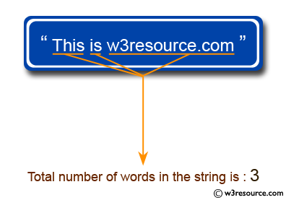
#include <stdio.h>
#include <string.h>
#include <stdlib.h>

#define str_size 100 //Declare the maximum size of the string

void main()
{
char str[str_size];
int i, wrd;

printf("\n\nCount the total number of words in a string :\n");
printf("------------------------------------------------------\n");
printf("Input the string : ");
fgets(str, sizeof str, stdin);

i = 0;
wrd = 1;

/* loop till end of string */
while(str[i]!='\0')
{
/* check whether the current character is white space or new line or tab character*/
if(str[i]==' ' || str[i]=='\n' || str[i]=='\t')
{
wrd++;
}

i++;
}

printf("Total number of words in the string is : %d\n", wrd-1);
}
Sample Output:
Count the total number of words in a string :
------------------------------------------------------
Input the string : This is w3resource.com
Total number of words in the string is : 3

- Write a program in C to extract a substring from a given string.
Test Data :
Input the string : this is test string
Input the position to start extraction :9
Input the length of substring :4

#include <stdio.h>
void main()
{
char str[100], sstr[100];
int pos, l, c = 0;

printf("\n\nExtract a substring from a given string:\n");
printf("--------------------------------------------\n");

printf("Input the string : ");
fgets(str, sizeof str, stdin);

printf("Input the position to start extraction :");
scanf("%d", &pos);

printf("Input the length of substring :");
scanf("%d", &l);

while (c < l)
{
sstr[c] = str[pos+c-1];
c++;
}
sstr[c] = '\0';

printf("The substring retrieve from the string is : \" %s\ "\n\n", sstr);

}
Sample Output:
Extract a substring from a given string:
--------------------------------------------
Input the string : This is test string
Input the position to start extraction :9
Input the length of substring :4
The substring retrieve from the string is : " test "

- Write a program in C to convert a string to lowercase.
Test Data :
Input a string in UPPERCASE : THE QUICK BROWN FOX JUMPS OVER THE LAZY DOG.

#include<stdio.h>
#include<ctype.h>

int main()
{
int ctr=0;
char str_char;
char str[100];

printf("\n Convert a string to lowercase :\n");
printf("----------------------------------");
printf("\n Input a string in UPPERCASE : ");
fgets(str, sizeof str, stdin);
printf(" Here is the above string in lowercase :\n ");
while (str[ctr])
{
str_char=str[ctr];
putchar (tolower(str_char));
ctr++;
}
return 0;
}

- Write a program in C to swap two numbers using function.
Test Data :
Input 1st number : 2
Input 2nd number : 4

#include<stdio.h>

void swap(int *,int *);
int main()
{

int n1,n2;
printf("\n\n Function : swap two numbers using function :\n");
printf("------------------------------------------------\n");
printf("Input 1st number : ");
scanf("%d",&n1);
printf("Input 2nd number : ");
scanf("%d",&n2);

printf("Before swapping: n1 = %d, n2 = %d ",n1,n2);
//pass the address of both variables to the function.
swap(&n1,&n2);

printf("\nAfter swapping: n1 = %d, n2 = %d \n\n",n1,n2);
return 0;
}

void swap(int *p,int *q)
{
//p=&n1 so p store the address of n1, so *p store the value of n1
//q=&n2 so q store the address of n2, so *q store the value of n2

int tmp;
tmp = *p; // tmp store the value of n1
*p=*q; // *p store the value of *q that is value of n2
*q=tmp; // *q store the value of tmp that is the value of n1
}
Sample Output:
Function : swap two numbers using function :
------------------------------------------------
Input 1st number : 2
Input 2nd number : 4
Before swapping: n1 = 2, n2 = 4
After swapping: n1 = 4, n2 = 2

- Write a program in C to calculate the sum of numbers from 1 to n using recursion.
Test Data :
Input the last number of the range starting from 1 : 5
#include<stdio.h>

int sumOfRange(int);

int main()
{
int n1;
int sum;
printf("\n\n Recursion : calculate the sum of numbers from 1 to n :\n");
printf("-----------------------------------------------------------\n");

printf(" Input the last number of the range starting from 1 : ");
scanf("%d", &n1);

sum = sumOfRange(n1);
printf("\n The sum of numbers from 1 to %d : %d\n\n", n1, sum);

return (0);
}

int sumOfRange(int n1)
{
int res;
if (n1 == 1)
{
return (1);
} else
{
res = n1 + sumOfRange(n1 - 1); //calling the function sumOfRange itself
}
return (res);
}
Sample Output:
Recursion : calculate the sum of numbers from 1 to n :
-----------------------------------------------------------
Input the last number of the range starting from 1 : 5

The sum of numbers from 1 to 5 : 15

- Write a program in C to Print Fibonacci Series using recursion.
#include<stdio.h>

int term;
int fibonacci(int prNo, int num);

void main()
{
static int prNo = 0, num = 1;
printf("\n\n Recursion : Print Fibonacci Series :\n");
printf("-----------------------------------------\n");

printf(" Input number of terms for the Series (< 20) : ");
scanf("%d", &term);
printf(" The Series are :\n");
printf(" 1 ");
fibonacci(prNo, num);
printf("\n\n");
}

int fibonacci(int prNo, int num)
{
static int i = 1;
int nxtNo;

if (i == term)
return (0);
else
{
nxtNo = prNo + num;
prNo = num;
num = nxtNo;
printf("%d ", nxtNo);

i++;
fibonacci(prNo, num); //recursion, calling the function fibonacci itself
}
return (0);
}

Sample Output:
Recursion : Print Fibonacci Series :
-----------------------------------------
Input number of terms for the Series (< 20) : 10
The Series are :
1 1 2 3 5 8 13 21 34 55

- Write a program in C to create and store information in a text file.
Test Data :
Input a sentence for the file : This is the content of the file test.txt.
#include <stdio.h>
#include <stdlib.h>

int main()
{
char str[1000];
FILE *fptr;
char fname[20]="test.txt";

printf("\n\n Create a file (test.txt) and input text :\n");
printf("----------------------------------------------\n");
fptr=fopen(fname,"w");
if(fptr==NULL)
{
printf(" Error in opening file!");
exit(1);
}
printf(" Input a sentence for the file : ");
fgets(str, sizeof str, stdin);
fprintf(fptr,"%s",str);
fclose(fptr);
printf("\n The file %s created successfully...!!\n\n",fname);
return 0;
}

Sample Output:
Create a file (test.txt) and input text :
----------------------------------------------
Input a sentence for the file : This is the content of the file test.txt

The file test.txt created successfully...!!

- Write a program in C to write multiple lines in a text file.
Test Data :
Input the number of lines to be written : 4
:: The lines are ::
test line 1
test line 2
test line 3
test line 4

#include <stdio.h>

int main ()
{
FILE * fptr;
int i,n;
char str[100];
char fname[20]="test.txt";
char str1;

printf("\n\n Write multiple lines in a text file and read the file :\n");
printf("------------------------------------------------------------\n");
printf(" Input the number of lines to be written : ");
scanf("%d", &n);
printf("\n :: The lines are ::\n");
fptr = fopen (fname,"w");
for(i = 0; i < n+1;i++)
{
fgets(str, sizeof str, stdin);
fputs(str, fptr);
}
fclose (fptr);
/*-------------- read the file -------------------------------------*/
fptr = fopen (fname, "r");
printf("\n The content of the file %s is :\n",fname);
str1 = fgetc(fptr);
while (str1 != EOF)
{
printf ("%c", str1);
str1 = fgetc(fptr);
}
printf("\n\n");
fclose (fptr);
return 0;
}
Sample Output:
Write multiple lines in a text file and read the file :
------------------------------------------------------------
Input the number of lines to be written : 4

:: The lines are ::
test line 1
test line 2
test line 3
test line 4

The content of the file test.txt is :

test line 1
test line 2
test line 3
test line 4

- Write a program in C to copy a file in another name.
Assume that the content of the file test.txt is :
test line 1
test line 2
test line 3
test line 4
Test Data :
Input the source file name : test.txt
Input the new file name : test1.txt
#include <stdio.h>
#include <stdlib.h>

void main()
{
FILE *fptr1, *fptr2;
char ch, fname1[20], fname2[20];

printf("\n\n Copy a file in another name :\n");
printf("----------------------------------\n");

printf(" Input the source file name : ");
scanf("%s",fname1);

fptr1=fopen(fname1, "r");
if(fptr1==NULL)
{
printf(" File does not found or error in opening.!!");
exit(1);
}
printf(" Input the new file name : ");
scanf("%s",fname2);
fptr2=fopen(fname2, "w");
if(fptr2==NULL)
{
printf(" File does not found or error in opening.!!");
fclose(fptr1);
exit(2);
}
while(1)
{
ch=fgetc(fptr1);
if(ch==EOF)
{
break;
}
else
{
fputc(ch, fptr2);
}
}
printf(" The file %s copied successfully in the file %s. \n\n",fname1,fname2);
fclose(fptr1);
fclose(fptr2);
getchar();
}

Sample Output:
Copy a file in another name :
----------------------------------
Input the source file name : test.txt
Input the new file name : test1.txt
The file test.txt copied successfully in the file test1.txt.

